**ISAD251 Application Factsheet**

* **The Application**

**This application is the MVC C# Web application project which is provide an online Pub shop platform for users to order different kinds of drink and foods via the website.**

**Features**

* + User will be able to view the different kind of drinks and foods on the website, and user can select what kind of product they want to view by clicking on to different category of the products
  + User can check the products from the products list and view the details information of each products.
  + User can add the products they want into their own shopping cart.
  + User can change the quantity of the ordered products or to remove them from their own shopping cart
  + User can place an order by clicking on the checkout function
  + User can cancel their own orders.
  + Admin can add new category to the category list.
  + Admin can delete the existing category name
  + Admin can add a new product
  + Admin can edit the existing product’s information
  + Admin can delete the product.
  + Admin can view the all customer’s order.
* **How It Works**

There will be two types of the user role: Admin & user

Example:

Admin account: admin

Password: pass

User account: john

Password: pass

* **Browser Testing**

My default Browser is Google Chrome and the Screenshot folder has all the screenshots,

so I will put the screenshot by using Microsoft Internet Explorer

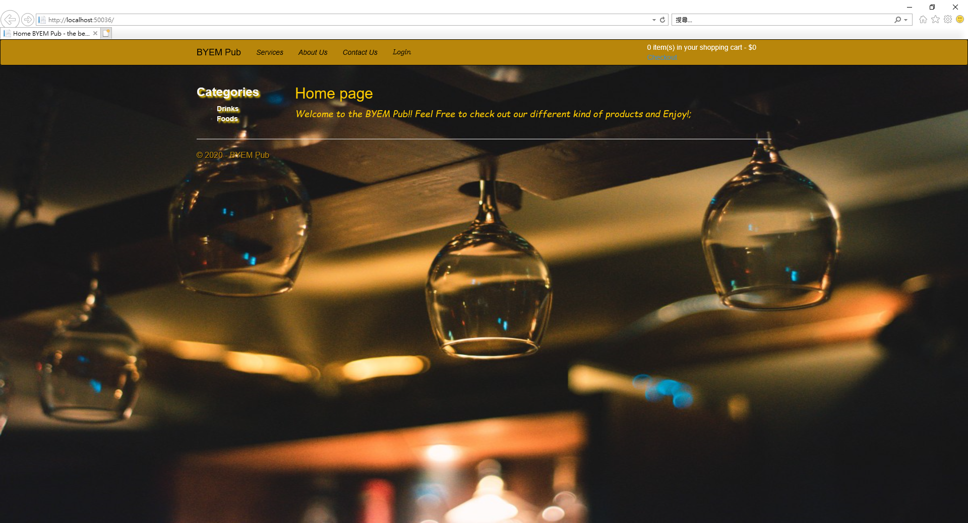

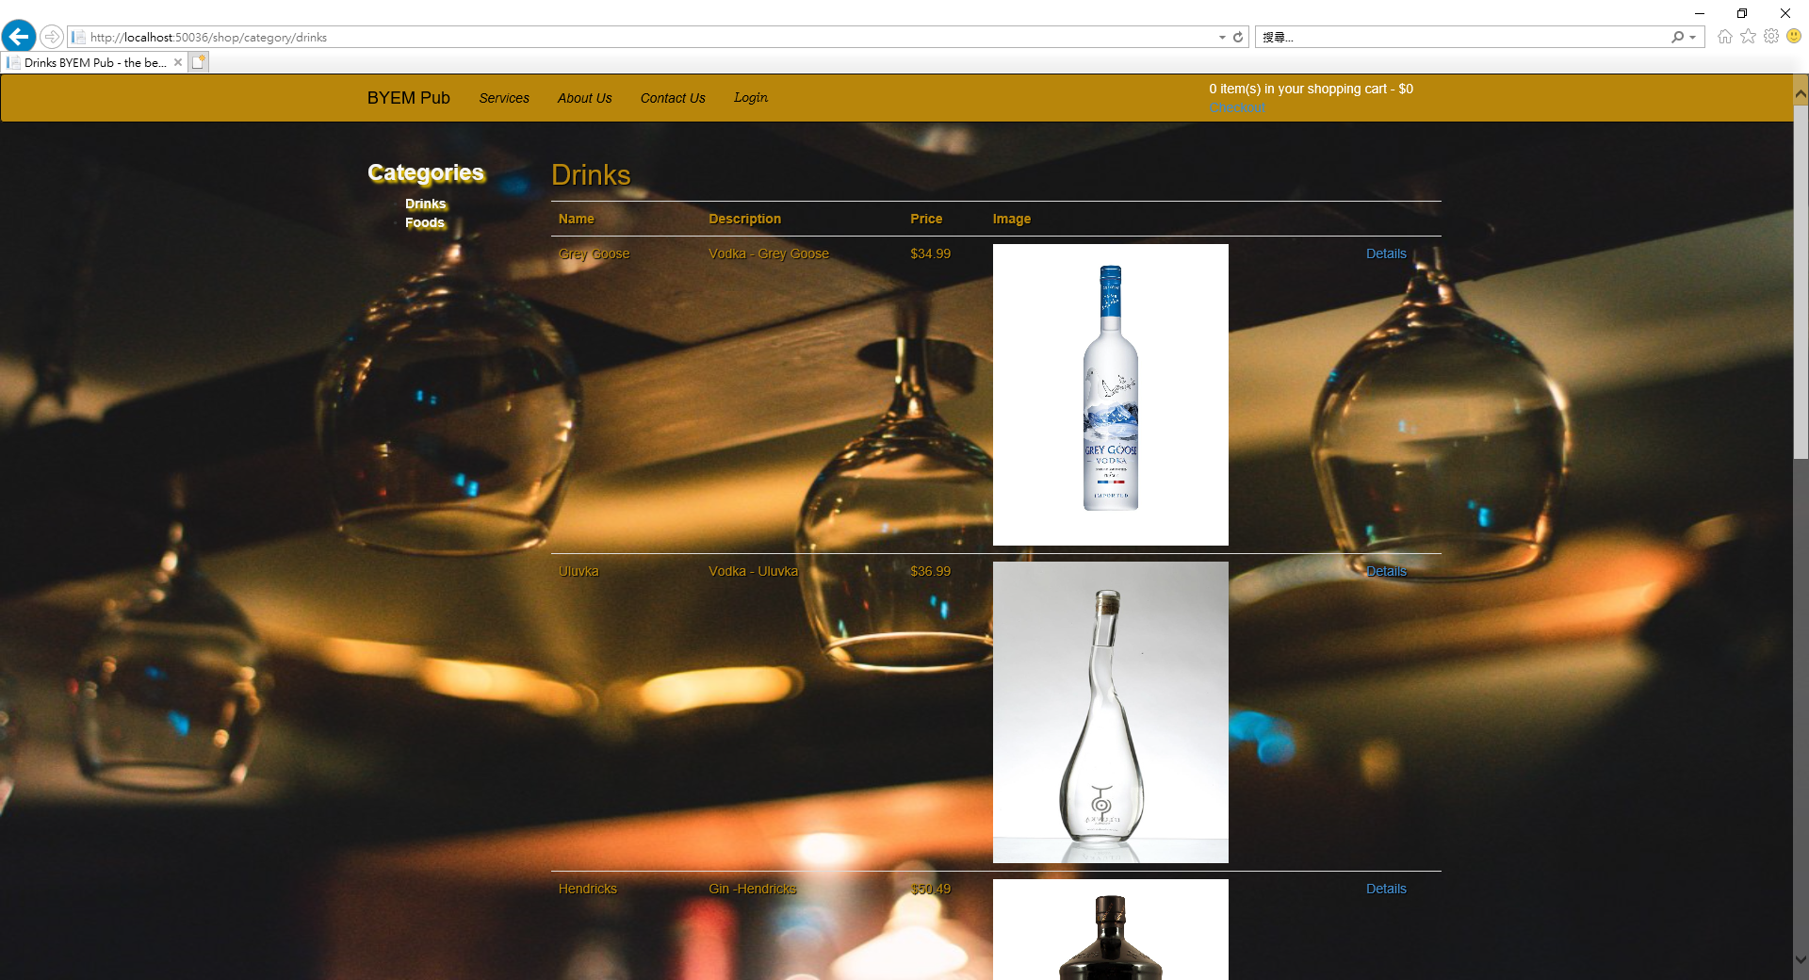

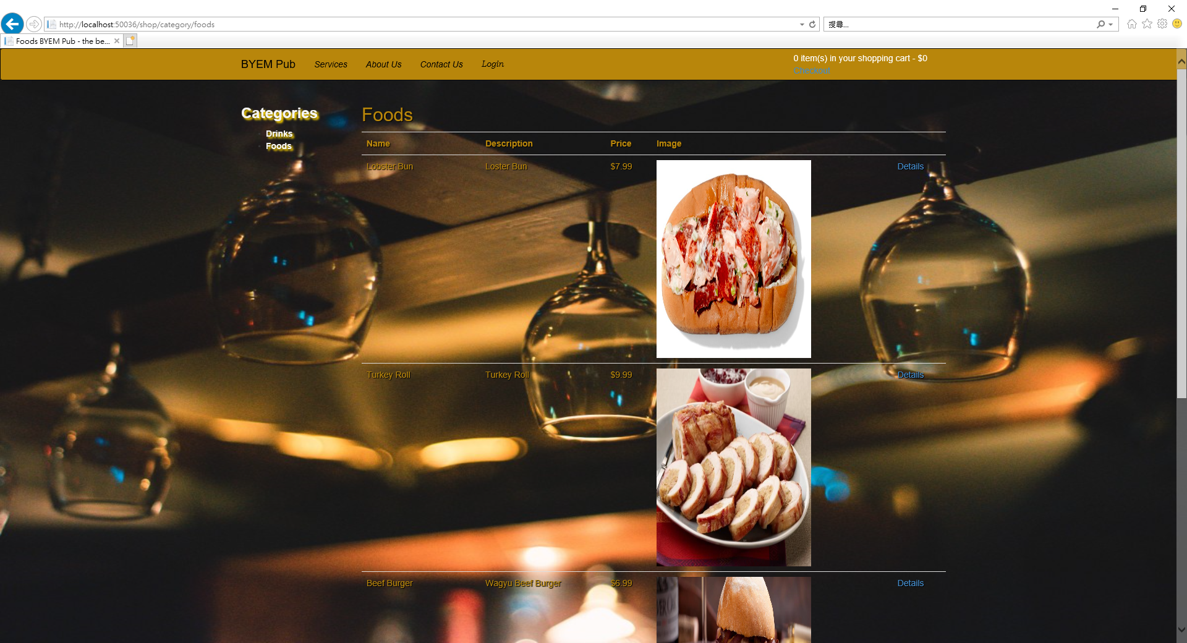

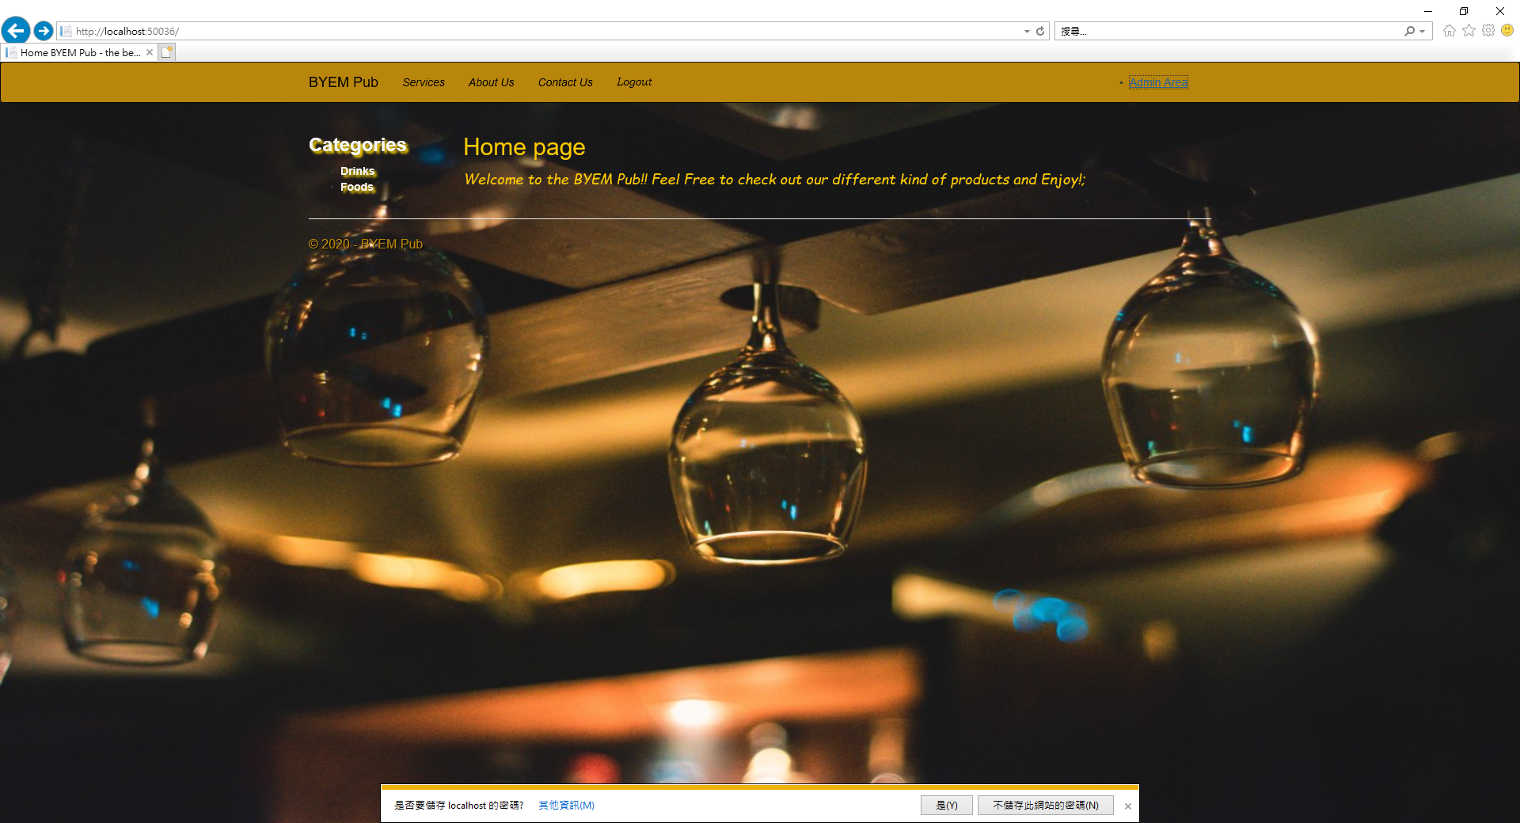

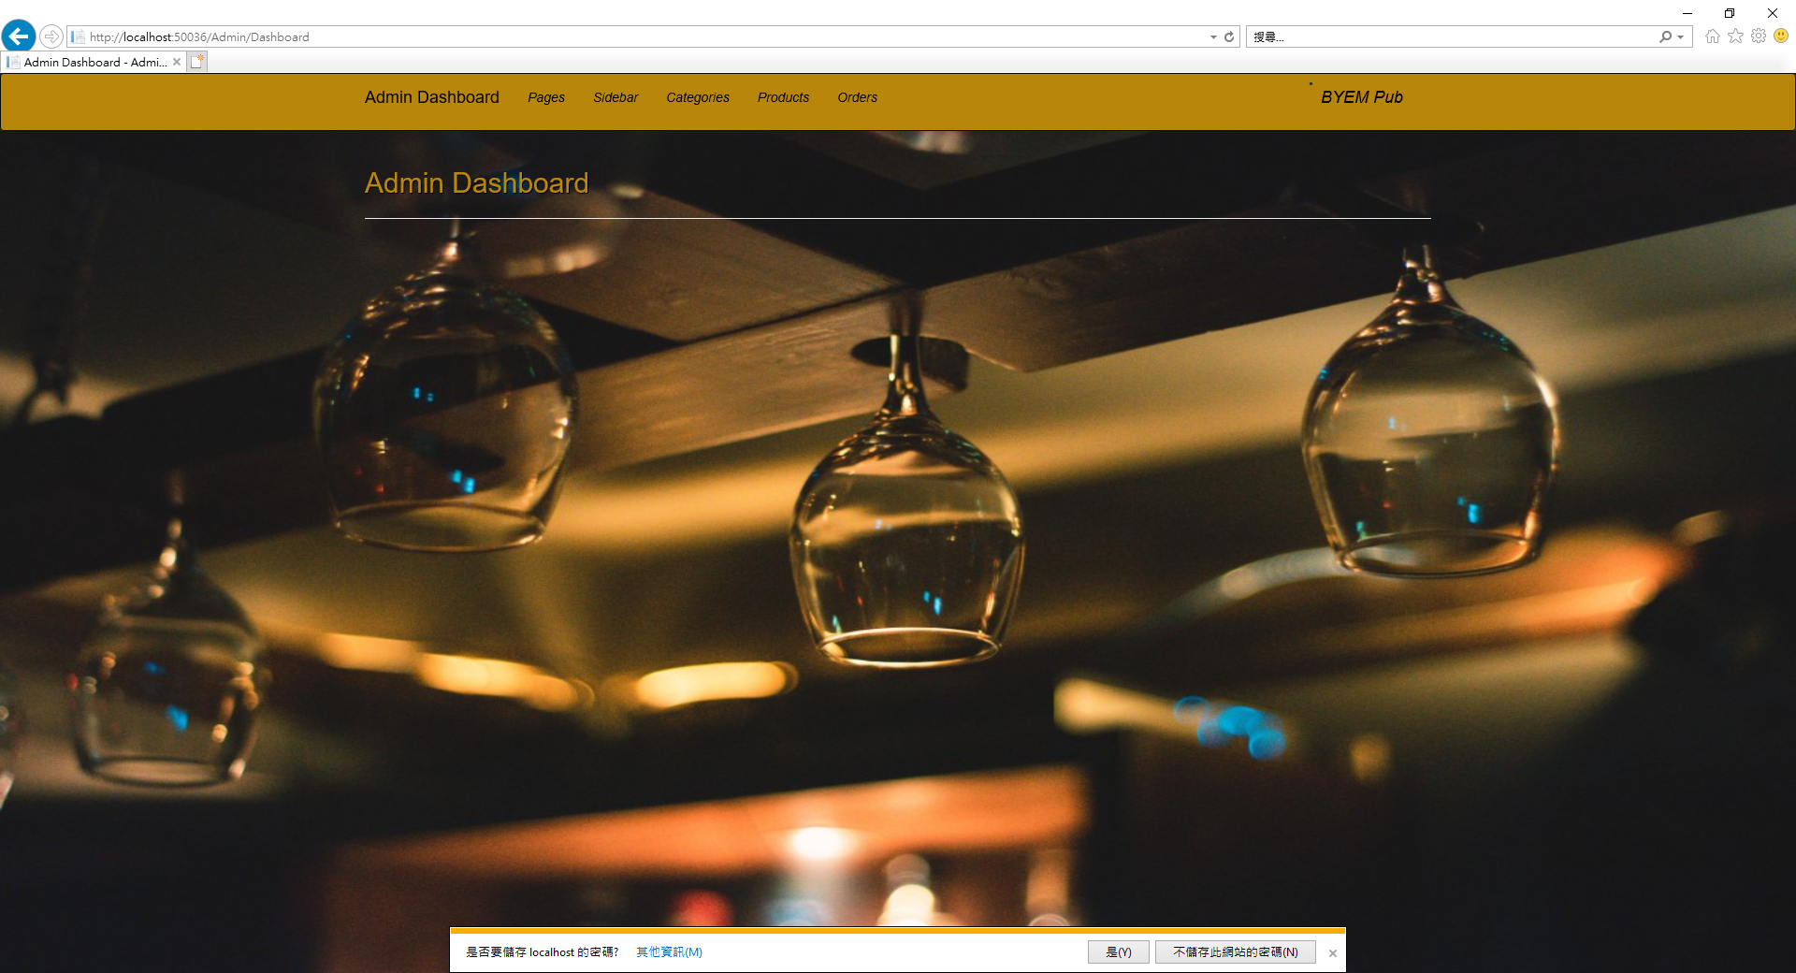

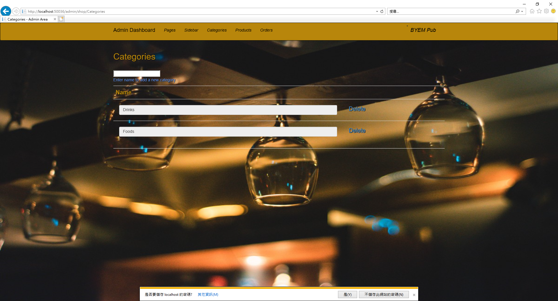

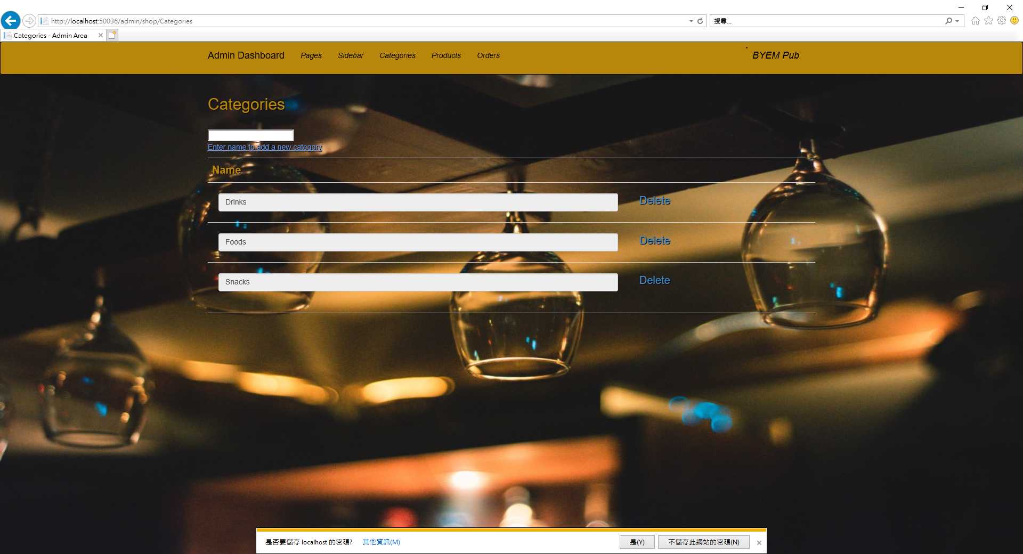

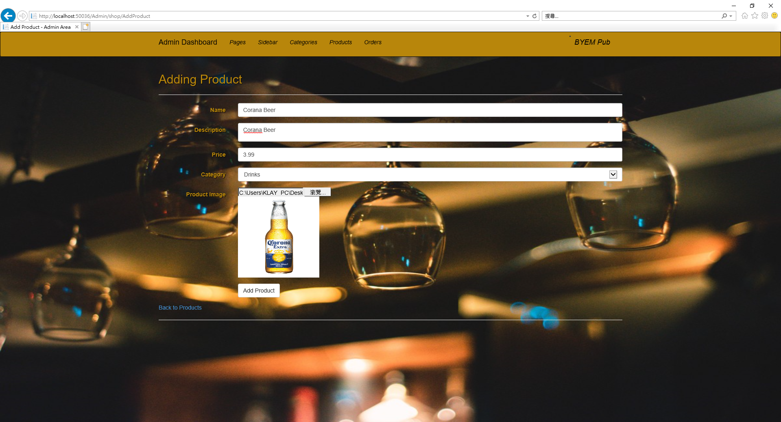

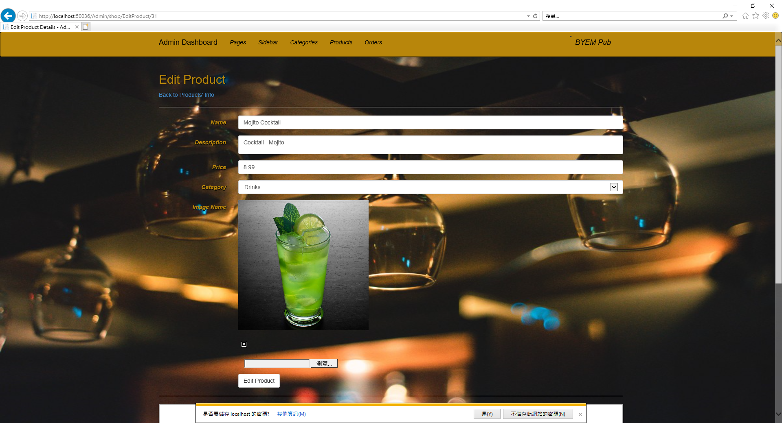

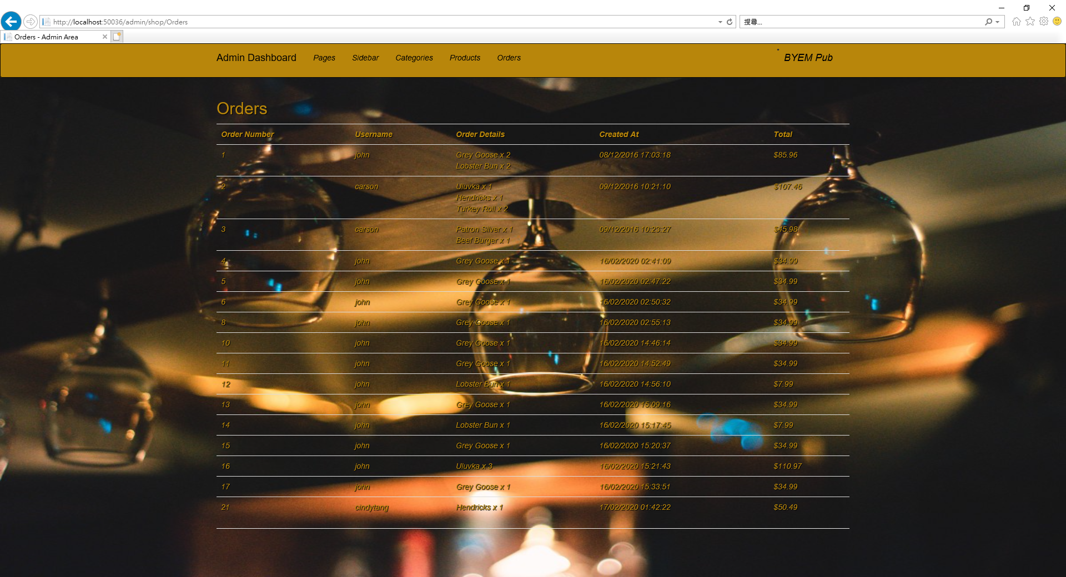

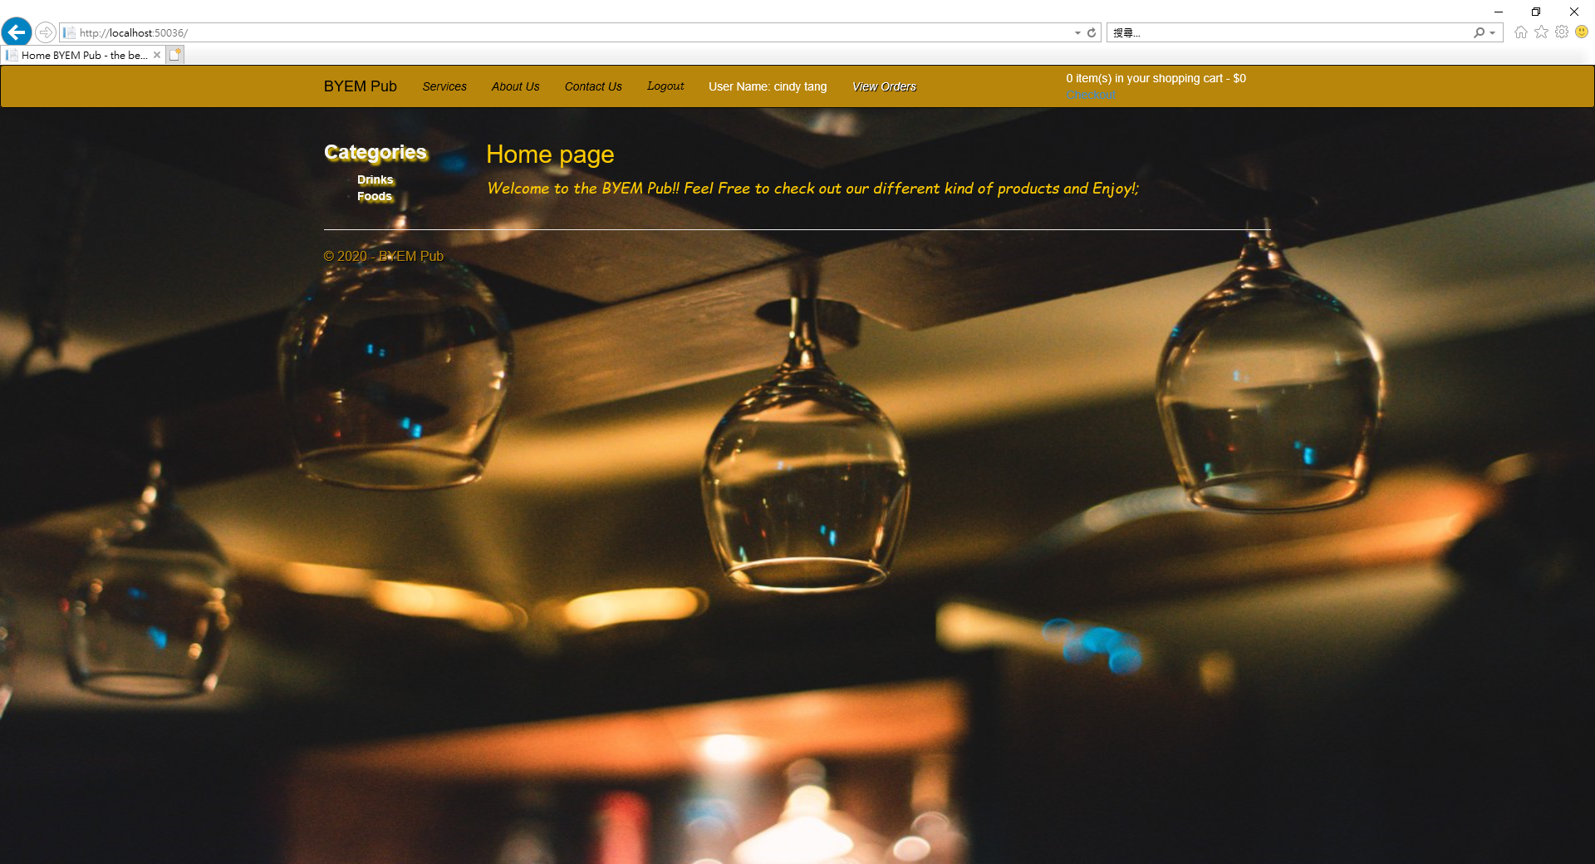

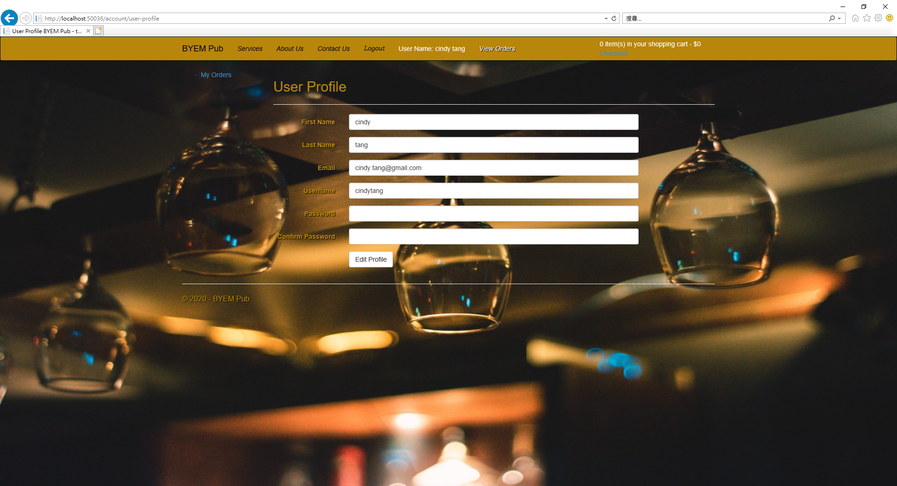

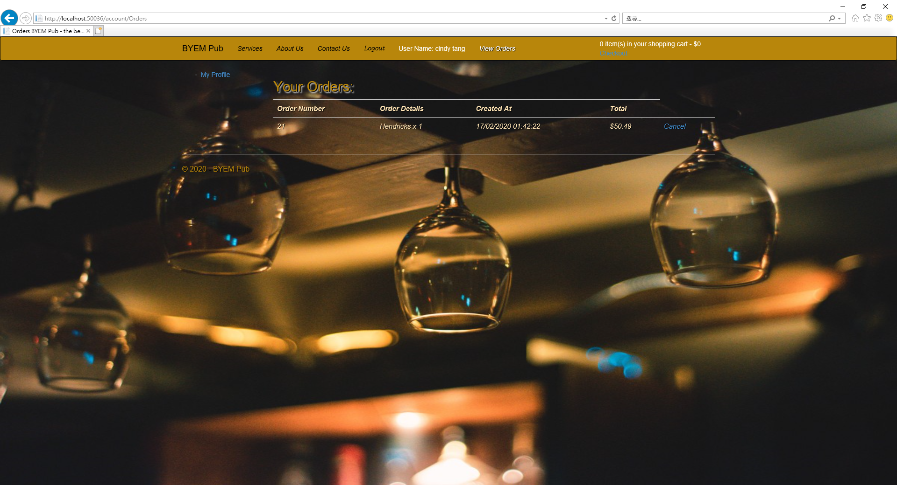

And the Project runs in IE normally.